Call to Worship

HYMN StF 20 Be Still https://www.youtube.com/watch?v=aJjz2rFc0lw
1 Be still, for the presence of the Lord,
the Holy One, is here;
come bow before him now
with reverence and fear:
in him no sin is found —
we stand on holy ground.
Be still, for the presence of the Lord,
the Holy One, is here.
2 Be still, for the glory of the Lord
is shining all around;
he burns with holy fire,
with splendour he is crowned:
how awesome is the sight —
our radiant King of light!
Be still, for the glory of the Lord
is shining all around.
3 Be still, for the power of the Lord
is moving in this place;
he comes to cleanse and heal,
to minister his grace:
no work too hard for him —
in faith receive from him.
Be still, for the power of the Lord
is moving in this place.
David J. Evans (b. 1957)
PRAYERS
Father God we come to you this morning to give thanks for all you have done for us, which is sometimes beyond our understanding. Sometimes we take your loving care for granted and for this we say sorry and will try to do better.
Thank you for sending your son Jesus to show us the way, the one who selflessly gave up his life for us that we might have eternal life. Often we do not appreciate what it cost to take the sins of the world upon yourself and take our relationship with you for granted. For this we say sorry and will try to do better.
Thank you for leaving your Holy Spirit with us to comfort us in times of trouble and open the path of reconciliation where the way forward seems impossible. We know that we cannot do your will unless you help us but so often we ignore your prompting and for this we say sorry and will try to do better.
We offer this prayer from hearts that are ready to say sorry for all that we have done that is wrong and all that we should have done but left undone.
In your name we pray.
Amen.
We say the Lord’s prayer together.
Our Father in heaven, hallowed be your name,
Your kingdom come, your will be done,
On earth as in heaven.
Give us today our daily bread.
Forgive us our sins as we forgive those who sin against us.
Lead us not into temptation, but deliver us from evil.
For the kingdom, the power and the glory are yours now and forever. Amen.
All Age Talk
Junior Church Prayer and Hymn Intro
Let us pray:
Father in heaven,
We thank you for the amazing, beautiful world you created. Help us to care for it.
We thank you for the wonderful, unique people you have made us to be. Help us to care for one another.
We thank you for the incredible, tasty food you have given us. Help us remember and care for those who are hungry.
We thank you for the inspiring stories and teaching in the Bible. Help us to share this good news with people everywhere.
Amen.
In Junior Church today, we are learning how King David brought the Ark of the Covenant into Jerusalem. He worshipped God wholeheartedly and enthusiastically, and the Bible tells us that David danced before the Lord with all his might and with shouts of joy. We will be thinking of lots of different ways that we too can praise God. We have chosen the hymn ‘You shall go out with joy’.
HYMN StF 487 You shall go out with joy https://www.youtube.com/watch?v=XCJ7BfLZm2Q
You shall go out with joy and be led forth with peace,
and the mountains and the hills shall break forth before you.
There'll be shouts of joy and the trees of the field
shall clap, shall clap their hands,
and the trees of the field shall clap their hands,
and the trees of the field shall clap their hands,
and the trees of the field shall clap their hands,
and you'll go out with joy.
Stuart Dauermann (b. 1944) and Steffi Geiser Rubin
Junior Church Blessing

READING: Romans 8:12-17 Life Through the Spirit
¹² Therefore, brothers and sisters, we have an obligation - but it is not to the flesh, to live according to it. ¹³ For if you live according to the flesh, you will die; but if by the Spirit you put to death the misdeeds of the body, you will live.
¹⁴ For those who are led by the Spirit of God are the children of God. ¹⁵ The Spirit you received does not make you slaves, so that you live in fear again; rather, the Spirit you received brought about your adoption to sonship. And by him we cry, “Abba, Father.” ¹⁶ The Spirit himself testifies with our spirit that we are God’s children. ¹⁷ Now if we are children, then we are heirs - heirs of God and co-heirs with Christ, if indeed we share in his sufferings in order that we may also share in his glory.
READING: John 3:1-17 Jesus Teaches Nicodemus
¹ Now there was a Pharisee, a man named Nicodemus who was a member of the Jewish ruling council. ² He came to Jesus at night and said, “Rabbi, we know that you are a teacher who has come from God. For no one could perform the signs you are doing if God were not with him.”
³ Jesus replied, “Very truly I tell you, no one can see the kingdom of God unless they are born again.”
⁴ “How can someone be born when they are old?” Nicodemus asked. “Surely they cannot enter a second time into their mother’s womb to be born!”
⁵ Jesus answered, “Very truly I tell you, no one can enter the kingdom of God unless they are born of water and the Spirit. ⁶ Flesh gives birth to flesh, but the Spirit gives birth to spirit. ⁷ You should not be surprised at my saying, ‘You must be born again.’ ⁸ The wind blows wherever it pleases. You hear its sound, but you cannot tell where it comes from or where it is going. So it is with everyone born of the Spirit.”
⁹ “How can this be?” Nicodemus asked.
¹⁰ “You are Israel’s teacher,” said Jesus, “and do you not understand these things? ¹¹ Very truly I tell you, we speak of what we know, and we testify to what we have seen, but still you people do not accept our testimony. ¹² I have spoken to you of earthly things and you do not believe; how then will you believe if I speak of heavenly things? ¹³ No one has ever gone into heaven except the one who came from heaven - the Son of Man. ¹⁴ Just as Moses lifted up the snake in the wilderness, so the Son of Man must be lifted up, ¹⁵ that everyone who believes may have eternal life in him.”
¹⁶ For God so loved the world that he gave his one and only Son, that whoever believes in him shall not perish but have eternal life. ¹⁷ For God did not send his Son into the world to condemn the world, but to save the world through him.
HYMN StF 167 Colours of Day https://www.youtube.com/watch?v=rwxAi12UiJ0
1  Colours of day dawn into the mind,  the sun has come up, the night is behind.  Go down in the city, into the street,  and let's give the message to the people we meet.  So light up the fire and let the flame burn,  open the door, let Jesus return.  Take seeds of his Spirit, let the fruit grow,  tell the people of Jesus, let his love show. | 2  Go through the park, on into the town;  the sun still shines on; it never goes down.  The light of the world is risen again;  the people of darkness are needing a friend.  3  Open your eyes, look into the sky,  the darkness has come, the sun came to die.  The evening draws on, the sun disappears,  but Jesus is living, his Spirit is near.  Sue McClellan, John Paculabo, Keith Ryecroft
Sermon: The Trinity
Some years ago, on a computer long-since discarded, I set up a template for Orders of Service. To save paper I wanted to print two orders side by side and cut it down the middle. I always set out my orders with the Church name, date and time centred in bold, an empty line space below, then below that the title or theme, also centred. It worked fine: once I had typed out the order, I copied and pasted it to the right-hand side of the page, and up it came, identical to the one already on the left. Then one day, for no apparent reason, something unexpected happened – the copied and pasted order on the right appeared without the line space in the title and continued to do that, no matter how I tried to correct it. I asked the advice of lots of people who knew much more about computers than I did, but no-one could explain it, and no-one could actually change it! To this day it remains a mystery, beyond the control of those who I deemed to be experts. I had no choice but to live with it, and work with it, always remembering to reinstate the line space before I printed off the sheet.
The doctrine of the Trinity is a mystery. The doctrine itself does not appear in any single passage of the Bible, New Testament or Old. Therefore, on Trinity Sunday those who put together the lectionary readings have to put together verses and passages which mention Father, Son and Holy Spirit, and variously speak about the relationship between Father and Son, Son and Holy Spirit, Holy Spirit and Father, and their relationship with human beings and creation.
So, there is no definitive passage in Scripture that explains the nature of the Trinity (i.e. One God in Three Persons). Yet clearly, from very early in the life of the Church, the Trinity was an essential part of Christian thinking, praying and teaching. I say ‘clearly’, but actually the idea of the Trinity is anything but clear. We Christians are adamant that we worship one God, and yet most of us pray, talk and act as though there are three. Think for a moment:
- To whom do you address your prayers? Always to one particular Person of the Trinity, or to all three equally?
- What is your ‘default’ image of God? When the word ‘God’ is mentioned what is the first picture or title that immediately flashes into your mind?
Some, it seems, relate naturally to God the Father, while for others, their own experience of fatherhood makes that image less helpful. Personally, I believe that Jesus’ strong identification of God with fatherhood speaks volumes about his relationship with Joseph. For those who do not have such positive experiences of fatherhood, perhaps the designation of this person of the Trinity as Creator might be more helpful, although it certainly loses something of the intimacy and self-giving love of fatherhood.
Others, understandably, relate more comfortably to Jesus, who, whilst truly God, shared our humanity and the experience of the limited and precarious life we lead.
Less easy, I think, is our relationship with the Holy Spirit. Is it because he (or she) is so difficult to pin down or envisage? Or maybe it is because she (or he) is the revealer and interpreter of the other two Persons, always pointing away from her/himself.
Why is the Trinitarian nature of God so difficult to grasp, explain or express? It is, I think, because the Trinity became known through the Christian experience of a mystery. The mystery of God’s nature, and what early Christians experienced of the true nature of God, was probably a shock for them!
Jesus’ Jewish disciples and converts would have been fiercely monotheistic. That there is only one true God was, and is still, at the core of Jewish faith and experience. At least once every day of their lives, Jewish men and women recite the Shema, ‘Hear, O Israel, the Lord our God is One.’ [Deuteronomy 6:4] This belief distinguished them from their pagan neighbours; to know who your God is, is to know who you are.
And then along came Jesus, this extraordinary man, who was a man sent by God, and yet seemed more than a man:
- he could command the wind and the waves
- he could feed thousands from a small basket of food,
- he could heal the sick with a word of command
- he could even raise the dead.
We have grown familiar with the idea of Jesus as the Son of God, but to his Jewish contemporaries the mere suggestion was blasphemy. To his disciples, Jesus Christ’s Sonship, was a growing awareness that had to be struggled with and eventually accepted with fear and trembling. When he died it must have seemed to them that they had misunderstood who he was, had in fact colluded in blasphemy! Then, God raised him from the dead, they met with him, talked with him, ate with him, and eventually concluded with joy, still tinged with fear, that whilst like us, he is not entirely like us – a God-man, the Son of God.
At Pentecost, five weeks after Jesus was raised, his disciples experienced another unexpected and unfathomable manifestation of God’s presence and power among them – the Holy Spirit.
- Where (or who) did it come from?
- What was its purpose?
- How did it work?
- Was it Jesus’ presence with them, or the Father’s, or was it God in its own right?
(Many years ago, a minister once said that he hated preaching on Trinity Sunday because, by the time he was 10 minutes into his sermon he would have preached at least one heresy! I’m now about 10 minutes in and I’ve probably uttered several! Maybe referring to the Holy Spirit as ‘it’, or maybe I have made the persons of the Trinity too separate, or perhaps you have spotted others.)
Let’s get back to those early Christians and their perplexing experience. Jewish Christians came to an understanding of the Trinity from a monotheistic viewpoint. For them, the Trinity, however it was experienced, must be essentially one. But most of the Gentiles who became Christians would have worshipped many gods (a pantheon), so separate deities were their ‘norm’. Each deity had a particular sphere of power and responsibility, and they struggled with one another, vying for power, using human beings as pawns in their hierarchical power games. Since Gentile Christians brought these assumptions of the divine into the Church, it was essential that the harmony, the love and the intimacy of the Trinity be emphasised. The nature of the Christian God and the relationship of the persons of the Trinity was so different from the relationship between the pagan gods!
Love, inter-dependence, unity, harmony within the Christian Godhead was not emphasized merely as a corrective to pagan assumptions. It was and is the truth. The God we worship is essentially relational in nature, and since we are created in the image of God, we human beings are also relational by nature. Difficult as it may be for us to hold two seemingly contradictory truths (One God: Three Persons) in perfect balanced tension, there is one key aspect of the mystery of the Trinity that we can surely grasp, applying its lessons to our own life. It is that the loving inter-dependence of the Persons of the Trinity, should be the pattern of our human relationships and the template of our human living. As individuals and as a Church, we are called to demonstrate by our words and deeds, to each other and to the world, the self-giving, inclusive love that lies at the heart of the God we worship, and gives life to all creation. Only by recognising our interdependence and our calling to love one another as Christ loved us [John 13:34-35] can we truly be God’s people, worthy to be called his children. Among the true disciples of Jesus Christ there is no place for anything, thought, word, or deed, that does not promote harmony, wellbeing and mutual appreciation of one another’s contribution to the work of God’s Kingdom. (Below Rublev’s Trinity, 15th century)
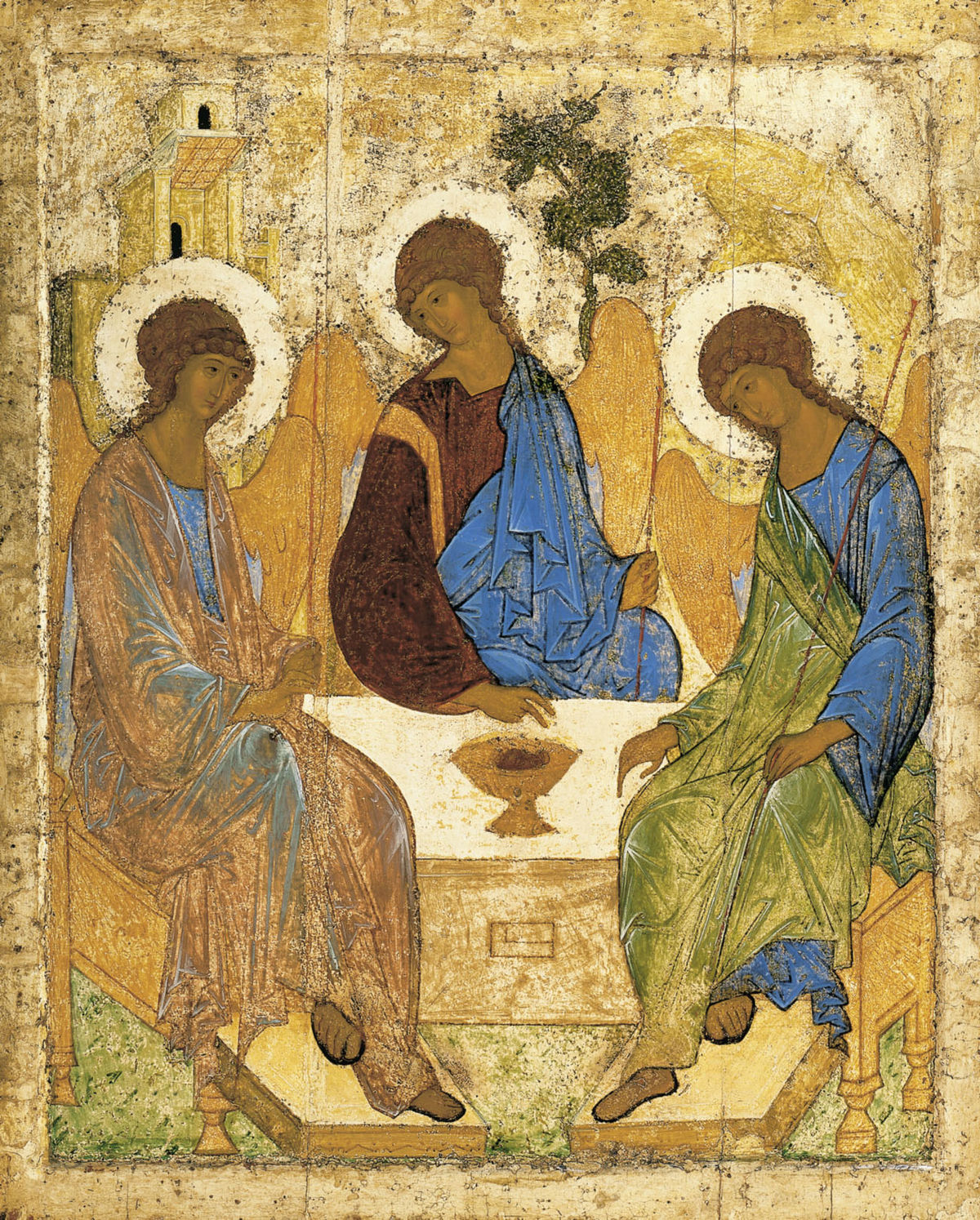HYMN StF 11 Holy, Holy, Holy
https://www.youtube.com/watch?v=M5OI4f605as
1
Holy, holy, holy, Lord God Almighty!
Early in the morning our song shall rise to thee:
holy, holy, holy, merciful and mighty,
God in three Persons, blessèd Trinity!
2
Holy, holy, holy! All the saints adore thee,
casting down their golden crowns around the glassy sea;
cherubim and seraphim falling down before thee,
who wert, and art, and evermore shalt be.
3
Holy, holy, holy! Though the darkness hide thee,
though the sinful human eye thy glory may not see,
only thou art holy; there is none beside thee,
perfect in power, in love, and purity.
4
Holy, holy, holy, Lord God Almighty!
All thy works shall praise thy name in earth and sky and sea;
holy, holy, holy, merciful and mighty,
God in three Persons, blessèd Trinity!
Reginald Heber (1783–1826) (alt.) Based on Revelation 4:8-11
PRAYERS OF INTERCESSION
We pray for Christians everywhere; for those in positions of authority over others, and for those with great responsibility in the life of the world.
For politicians who are genuinely seeking to serve God and live by their faith in Christ; for those who live for Christ in the corridors of power and name your name in the face of ridicule and rejection. May they know the strength and humility of Christ.
We pray that the people of God will have that knowledge of the dying and rising Christ and the power of the spirit that will enable them to speak your truth with power. May all your people be filled with confidence, with the certainty of its faith in Christ and in the power of self-giving love.
We pray for Christians who have become disillusioned; who made their commitment to Christ many years ago but have allowed their hearts to grow cold and their worship to become infrequent. For those who have allowed the world and its attitudes to write their agenda, for those whose faith is weak and those whose knowledge of Christ has failed to grow. May they feel again the life-changing, life-renewing power of the Holy Spirit.
We pray for the troubles of this world, for those who are victims of a society that is self-seeking and closes its eyes to the weak, the hungry and the marginalised. May this world of yours be inclusive as you showed your followers when you was here on earth. We pray for those places which are still filled with hatred for one another. We think especially of Israel and Palestine still warring over the Gaza Strip. Where we see no way forward we pray that your reconciling love will find its way into the hearts of those who hold the power in these situations.
We pray for the whole church of Jesus Christ. We thank you for the hope, joy, peace and heaven that you have given us in Christ. We ask that you will enrich our worship, empower our witness and transform our service in the world. We pray that your presence and power may be seen in everything we say and do together.
(Opportunity for others to bring their prayers)
We bring our prayers in and through your son Jesus Christ.
Amen.

HYMN StF 21 Born in Song https://www.youtube.com/watch?v=XykRVyd2gTM
1  Born in song!  God's people have always been singing.  Born in song!  Hearts and voices raised.  So today we worship together;  God alone is worthy to be praised.  2  Praise to God!  For he is the one who has made us.  Praise to God!  We his image bear.  Heaven and earth are full of his glory;  let creation praise him everywhere.  3  Christ is King!  He left all the glory of heaven.  Christ is King!  Born to share in our pain,  crucified, for sinners atoning,  risen, exalted, soon to come again. | 4  Sing the song!  God's Spirit is poured out among us.  Sing the song!  He has made us anew.  Ev’ry member part of the Body;  given his power, his will to seek and do.  5  Tell the world!  All power to Jesus is given.  Tell the world!  He is with us always.  Spread the word, that all may receive him,  every tongue confess and sing his praise.  6  Then the end!  Christ Jesus shall reign in his glory.  Then the end  of all earthly days.  Yet above the song will continue,  all his people still shall sing his praise.  Brian Hoare (b 1935)

Blessing
May the Sending One sing in you,
May the Seeking One walk with you,
May the Greeting One stand by you,
In your gladness and in your grieving.
May the Gifted One relieve you,
May the Given One retrieve you,
May the Giving One receive you,
In your falling and your restoring.
May the Binding One unite you,
May the One Beloved invite you,
Three-in-One, joy in life unending.
Amen
Brian Wren

____________________________________________________________
CCLI number 482115

